1. Diagnosis
   1. Alzheimer’s disease
      1. <https://www.kaggle.com/datasets/tourist55/alzheimers-dataset-4-class-of-images>
   2. Cardiology
      1. <https://www.sciencedirect.com/science/article/pii/S2352914819304009>
         1. U-Net based architecture
         2. we obtained a [diagnostic accuracy](https://www.sciencedirect.com/topics/computer-science/diagnostic-accuracy) greater than 93%
         3. CXR image
      2. <https://www.kaggle.com/datasets/nih-chest-xrays/data>
   3. Bones fracture
      1. <https://www.sciencedirect.com/science/article/pii/S2665917423000594#:~:text=The%20canny%20edge%20detector%20can,detect%20lower%20leg%20bone%20fractures>.
      2. <https://www.kaggle.com/datasets/vuppalaadithyasairam/bone-fracture-detection-using-xrays> [Fractured or not]
   4. **Dermatology Assistance**
      1. Implement a feature that uses computer vision to analyze skin conditions from images. This can help with the diagnosis of dermatological issues, including identifying moles or skin lesions.
   5. Ophthalmology Support
      1. Integrate computer vision to analyze retinal scans, fundus images, or other eye-related images. This can aid in the early detection of eye diseases like diabetic retinopathy or glaucoma.
   6. **Remote Wound Assessment**
      1. Enable doctors to assess wounds and injuries through images or videos, and use computer vision to track healing progress over time.
   7. Dental **Image Analysis**
      1. Add features for analyzing dental X-rays or intraoral images to aid in the diagnosis of dental conditions.
      2. <https://www.researchgate.net/publication/349656440_Object_detection_on_dental_x-ray_images_using_deep_learning_method/link/608ed8e2299bf1ad8d728a23/download>
      3. <https://www.hindawi.com/journals/cin/2022/3500552/>

* + 1. Data Set
       1. <https://www.kaggle.com/datasets/daverattan/dental-xrary-tfrecords>

1. Report Generation
   1. <https://medium.com/analytics-vidhya/medical-report-generation-using-deep-learning-87b50096ead0>

Often time, it is the duty of a radiologist to conclude these x-rays so that to give appropriate treatment to the patients. It is often time-consuming and tedious to get detailed medical reports from these x-rays.

However, the medical report generated from the model should be confirmed by a radiologist in the final stage.

Data Set:

* the data given by the Indiana University hospital network
* chest x-rays and corresponding medical reports are provided
  1. <https://github.com/vysakh10/Medical-Report-Generation-using-Deep-Learning> [Chest X ray]

1. NLP Assistance
   1. No code or dataset
   2. But there is a paper <https://paperswithcode.com/paper/extracting-symptoms-and-their-status-from>
   3. https://www.ncbi.nlm.nih.gov/pmc/articles/PMC9203765/

* 1. **AI for Multi-Modal Data Fusion**: Develop AI systems that can combine and analyze data from various sources, such as medical images, electronic health records, genomic data, and wearable sensor data to provide a more comprehensive and accurate diagnosis.
  2. **AI for Lung Disease Detection**: Design AI systems that can analyze lung sounds and images to diagnose respiratory conditions, such as asthma, OPD, and lung infections

1. Medicine Recommendation
   1. Drug recommendation System used in health care using ML
      1. <https://www.kaggle.com/code/mpwolke/medicine-recommendation/notebook>
      2. A screenshot of a computer

         Description automatically generated
      3. A screenshot of a computer

         Description automatically generated
   2. DRUG RECOMMENDER SYSTEM USING MACHINE LEARNING FOR SENTIMENT ANALYSIS
      1. Just review no code or implementation
      2. <https://www.irjmets.com/uploadedfiles/paper/issue_7_july_2023/43424/final/fin_irjmets1690118387.pdf>
      3. Idea: It ranks medications based on positive sentiment ratings, ensuring better user happiness and efficacy. The system also considers negative reviews to prevent prescribing medicines with unfavorable emotions, preventing unfavorable consequences or patient dissatisfaction.
      4. The Drug Recommender System utilizes machine learning for sentiment analysis to assist patients and medical professionals in making informed decisions about drug prescriptions and treatments.
      5. This advanced strategy utilizes big data and sophisticated analytics to analyze user sentiment and emotions in text data. By utilizing machine learning algorithms, the system extracts and categorizes attitudes, providing valuable insights on medication effectiveness, adverse effects, and patient satisfaction.
      6. Our approach combines sentiment analysis with drug recommendation algorithms to optimize medicine selection, improve patient outcomes, and reduce adverse reactions.
      7. ArchitectureA diagram of a system architecture

         Description automatically generated
   3. Drug Recommendation System in Medical Emergencies using Machine Learning
      1. IEEE Samir
      2. https://ieeexplore.ieee.org/document/10099607
      3. Medication is given based on the patient's symptoms, blood pressure, diabetes, temperature, and other parameters.
   4. Take Availability into consideration
2. Report Generation
   1. Clinically Accurate Chest X-Ray Report Generation
      1. <https://paperswithcode.com/paper/clinically-accurate-chest-x-ray-report/review/>
      2. we present a domain-aware automatic chest X-ray radiology report generation system
         1. first predicts what topics will be discussed in the report
         2. then conditionally generates sentences corresponding to these topics.
      3. Data sets:
         1. Open-I (Next Article has links for this data set)
         2. MIMIC-CXR,
      4. A diagram of a machine

         Description automatically generated
   2. Paper using Open-I as data set
      1. <https://rohansoni-jssaten2019.medium.com/indiana-university-chest-x-rays-automated-report-generation-38f928e6bfc2>
      2. Data: Open-i has a collection of chest X-Ray Images from the Indiana University hospital network. Data contains two folders, one for X-ray Images and the other for the XML report of radiography. For each report, there could be multiple images
         1. A screenshot of a computer screen

            Description automatically generated
   3. **ChestX-ray8** (Data Set)
      1. **ChestX-ray8** is a medical imaging dataset which comprises 108,948 frontal-view X-ray images of 32,717 (collected from the year of 1992 to 2015) unique patients with the text-mined eight common disease labels, mined from the text radiological reports via NLP techniques.
      2. <https://www.kaggle.com/datasets/nih-chest-xrays/data>
      3. 45 GB
      4. Localization Just is the issue
      5. <https://www.kaggle.com/datasets/nih-chest-xrays/data>
      6. A close-up of a x-ray

         Description automatically generated
   4. ~~Stanford~~
      1. <https://www.researchgate.net/publication/359348795_Report_Generation_of_Lungs_Diseases_from_Chest_X-ray_using_NLP/link/623649b3d1e27a083bbc7c97/download>
      2. A diagram of a lung

         Description automatically generated
   5. A dataset of chest X-ray reports annotated with Spatial Role Labeling annotations
      1. <https://data.mendeley.com/datasets/yhb26hfz8n/1>
      2. This dataset consists of 2000 chest X-ray reports (available as part of the Open-i image search platform) annotated with spatial information. The annotation is based on Spatial Role Labeling
      3. 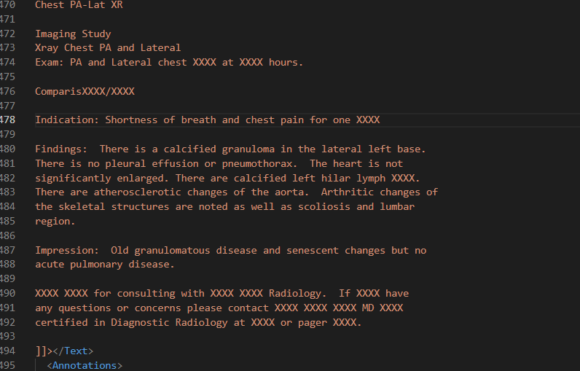
   6. VinDr-CXR: The largest public chest X-ray dataset with radiologist-generated **annotations** for machine learning-based computer-aided diagnosis (CAD)
      1. <https://researchdata.springernature.com/posts/vindr-cxr-the-largest-public-chest-x-ray-dataset-with-radiologist-generated-annotations-for-machine-learning-based-computer-aided-diagnosis-cad>
      2. <https://www.kaggle.com/competitions/vinbigdata-chest-xray-abnormalities-detection/data?select=train> [Competition] 200GB
      3. Most existing chest radiograph datasets depend on automated rule-based labelers that either use keyword matching or an NLP model to extract disease labels from free-text radiology reports.
      4. There are a few CXR datasets that include annotated locations of abnormalities but they are either too small for training deep learning models or not detailed enough.
      5. A diagram of a computer

         Description automatically generated